**VM insights**

VM insights monitors the performance and health of your virtual machines and virtual machine scale sets, including their running processes and dependencies on other resources.

VM insights supports Windows and Linux operating systems on the following machines:

* Azure virtual machines
* Azure virtual machine scale sets
* Hybrid virtual machines connected with Azure Arc
* On-premises virtual machines
* Virtual machines hosted in another cloud environment

VM insights stores its data in Azure Monitor Logs

There's no direct cost for VM insights, but you're charged for its activity in the Log Analytics workspace

* Data ingested from agents and stored in the workspace.
* Health state data collected from guest health (preview)
* Alert rules based on log and health data.
* Notifications sent from alert rules.

## **Configuring VM insights**

1. It deploys the Log Analytics agent to your VM.
2. It installs the Dependency agent on your VM.
3. It installs some workbooks to visualize this data.

## **View performance**

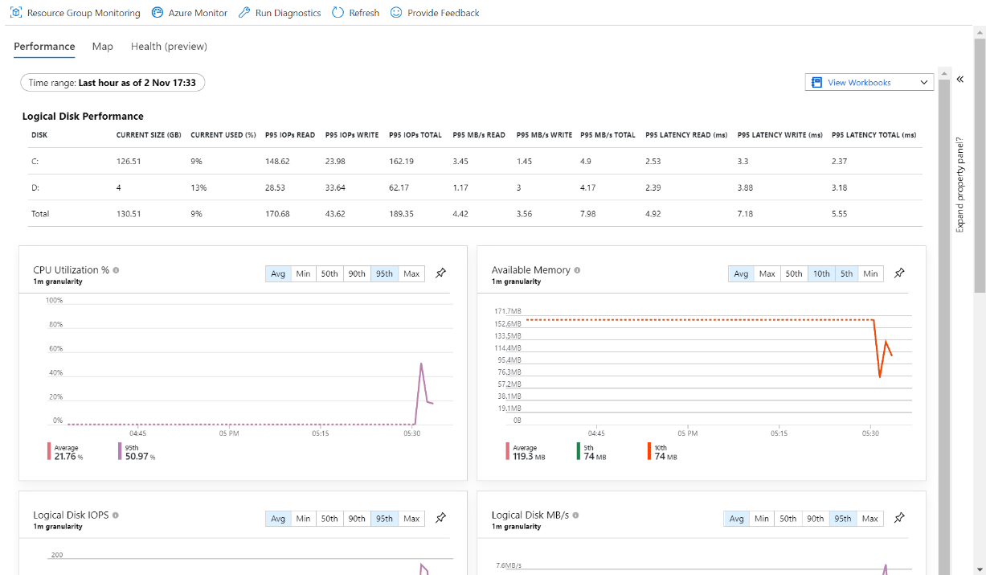

## **View processes and dependencies**

